

February Newsletter

Trending topics

Most of you by now have heard about Enoch Burke. For those who have not I commend you for not listening to the news. In any case he is a secondary school teacher who was first suspended by his school and later dismissed. His offence appears to be his decision not to refer to a student who was transgendering as “they” or whatever new title they requested.

Without demonising Enoch or his employer which was the school board, there are a few life lessons that we can learn. In that situations there only appears to be losers, Mr. Burke, the school, the student at the centre of the debacle, and the other students.

First lesson is that disagreements will and do arise in the work place, at home or at play. The Irish psyche is not known for our abilities to resolve conflict. Our civil war of less than one hundred years ago saw brother fight against brother for dear olde Ireland. When a dispute arises and it will happen it is better for both parties to sit down and discuss the issues involved. This involves active listening and mutual respect. Many times misunderstandings can easily arise, or someone only gets half the story. Sometimes a mediator is necessary. The important issue here is to see if the issue can be resolved at the earliest opportunity.

Twenty years ago I was in a dispute with a work colleague wherein we both worked for an organisation with a board of directors. The board met each of us individually and said that each of us was headstrong but that when we worked together and shared ideas we were a very good team. We both reassessed our position, realised the board were right, and resolved our differences. We made some agreed changes to how we worked and the outcome was positive for all concerned.

Recently I was told about how an eleven-year-old primary student complained that her class mate was upsetting her daily. The school was emailed and the mother shared her concerns with the principal. The principal reported later in the day that both students had met and resolved their issues together with the teacher as facilitator. And I would have to say, well done principal and well done to the students and the parents.

I am not saying that all disputes can be settled easily but many issues could be resolved by that honest and frank discussion. I remember issues that were never resolved whilst I was growing up in Tipperary. Two farmers who were neighbours fell out over a “right of way”. They would not talk and there was threats of law and courts and who was right and who was wrong. A short few years later as I drive past both farmers had since died. The right of way was overgrown with briars and thorny bushes from lack of use. No one cared anymore.

When I was about 14 years old and my older brother was just over 17 years old our neighbour fooled us on April the 1st. One brother told us his elderly brother needed help on the farm and we went immediately to help. My older brother never spoke to this neighbour again while he lived which must have been another fifteen years. Coincidently this same brother stopped speaking to me over two years ago and I am not totally sure of the reason. I have made gestures by text and email over the two years but no response so far. I have decided to wait for him to make the next move. And recently he asked my sister how I was so there is hope. Unless a person tells you why they are upset you may never know. Sometimes despite our best efforts reconciliation does not happen. We have little choice but to accept this and make our peace with same. It is always good to be open to reconciliation and it is cathartic when it all works out.

There is a bible phrase which states " a soft answer turned away wrath and grievous words stir up anger. Enoch Burke as a declared Christian should be familiar with this Proverb. This case proves that when a dispute continues it always gets more difficult to resolve and there are no winners.

Joseph Peters- General Manager



Pictured above – Joseph Peters (General Manager) and Joy Berey (Director of Nursing)

Introducing our new Staff

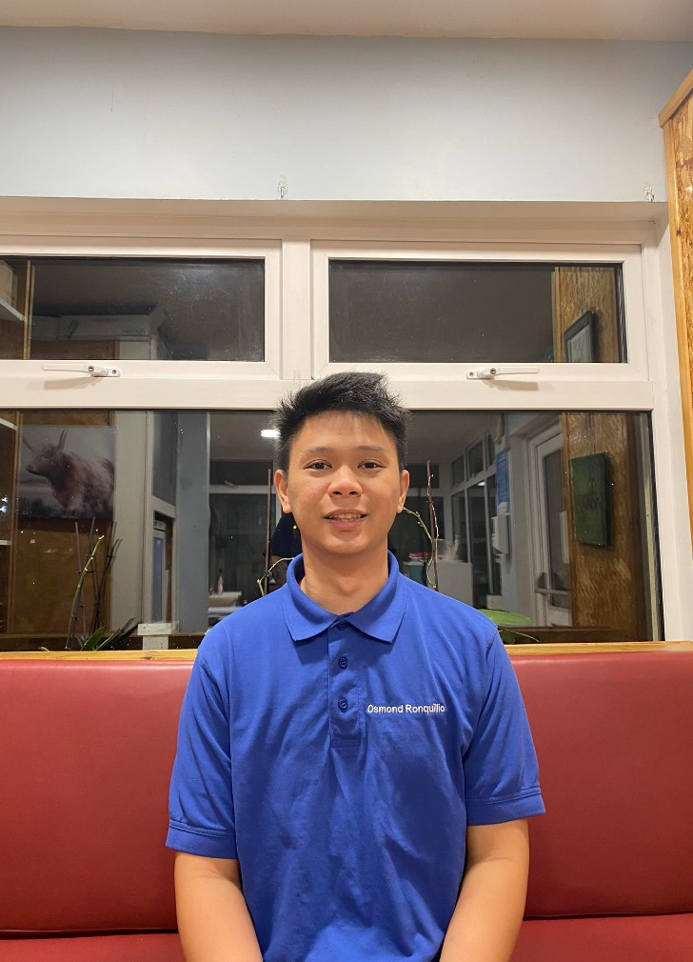
Osmond Ronquillo is an enthusiastic, kind and patient HCA.

My mother was living and working as a nurse in Ireland and I always wanted to come here and join her. Many applications for visas were refused until last year when health care workers were added to the critical skills visa programme.
Once I made the decision to come to Ireland, I began a six month course to train as a health care assistant. I graduated and then I applied for my visa to come here.

My perception of Ireland so far is peaceful and relaxed. I come from a city of 600 thousand people, called Bacolod. Bacolod is very busy city with constant traffic and pollution. Irish people are very friendly and welcoming. I like the cold, surprisingly. In the Philippines, you are always hot unless you are under the air conditioner.
I am genuinely surprised at how grateful residents are for the care we provide. We are paid for what we do and yet the residents always thank us.

I helped take care of my grandmother in Philippines until she passed away last year. She was 93 and she was a great influencer on my life. She was a remarkable woman who helped so many people in her life whenever she had the opportunity.
I am incredible grateful to be in Ireland and reconnect with my baby brother who I have not seen in five years. This baby is 20 years old now. I also got to meet my three sisters for the first time. These are amazing reunions and have brought such happiness in my life. Seeing my mother daily is unbelievable. Her cooking is amazing. It was a long wait to get here but the reunion is as sweet as a basket of ripe mangoes.

Right now I am enjoying the present, not thinking too much about the future, soaking in all the good things in my life. When a dream comes true you have to savour the experience as life will always have challenges.

Osmond Ronquillo- HCA

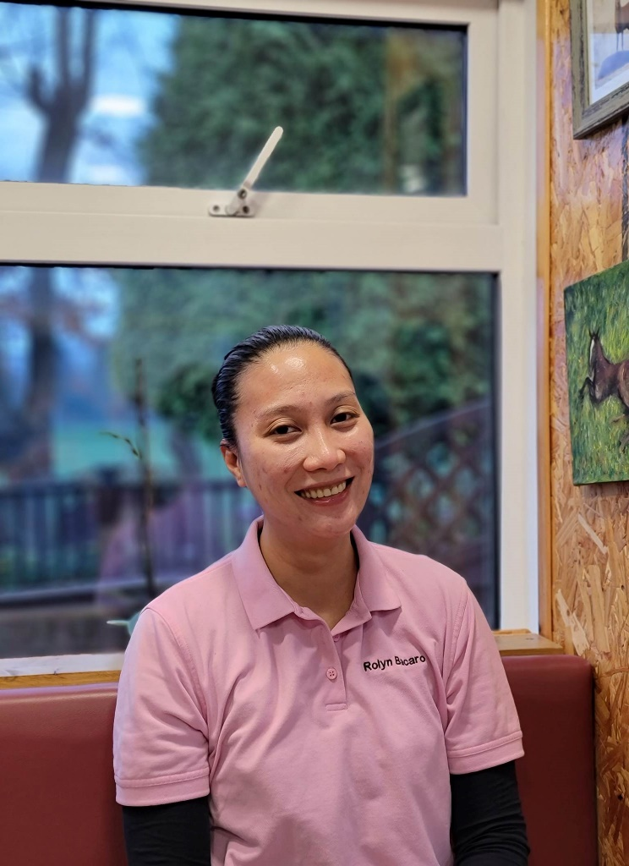
Rolyn is caring, patient and compassionate HCA.

My name is Rolyn and I have just begun my career as a health care assistant at J.C.P. Powdermill. I arrived in Ireland mid-January 2022.

I have relatives living and working in Ireland for many years now. I remember when I was in elementary school (primary here) aged 11, my cousin Grace was a nurse in Ireland. I thought then, that this is what I want to do. My aunt Aileen started working in Ireland in 2017 as a nurse at JCP Powdermill. She started to support me through college as a nurse. I completed two years successfully and then I became a mother and could not do both successfully.

Aileen suggested when the laws changed, that she would assist me to come to Ireland. Last year, I enrolled in a course for six months to train as a health care assistant. I graduated the course and here I am….
I am very lucky to have Aileen as an aunt. She has always been very kind and generous to me and maybe a little strict!! Truly she is very good to me and she is helping me to become self-reliant.

Of course, I miss my family. I try to call as often as I can. My son is at school and there is a large time difference between Ireland and the Philippines. I lived next door to my grandparents so we always shared great family time.

I would love to train as a Nurse if Powdermill would support and guide me in the future. Joe and Joy have assured and informed me “Powdermill is proud to have been able to assist six health care assistants go on to become wonderful and caring nurses”

I feel as though I am on a journey of redemption here in Ireland.

Rolyn comes from the city of smiles - Bacolod, Negros Island and she has certainly brought one of the city smiles with her.

We wish her the very best for the future and look forward to having her as part of the Powdermill team.

Rolyn Bacaro - HCA

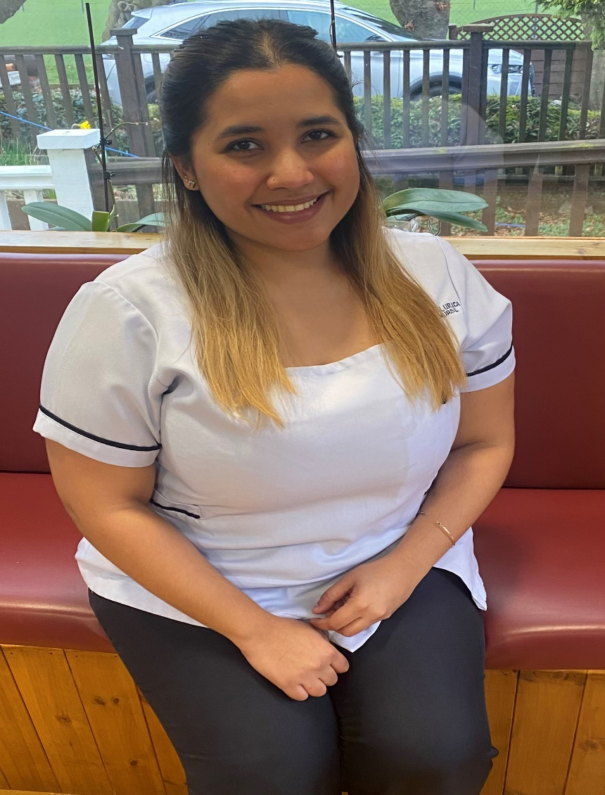
Introducing Faith Love Lurica, our new Staff Nurse. Faith is gentle, smart and efficient.
My name is Faith Love Lurica. I was born and raised in the Philippines. I am 25 years old and have a Bachelor of Science in Nursing. Since I was young, I have always had the passion to serve and help people who are in need.
I became interested in healthcare because of my mom, who is also a nurse. She has shown me how wonderful and rewarding it is to have this kind of noble job. When I was younger, I always wanted to become a doctor. It is really my dream, but due to financial insufficiency and how difficult it is to earn in a third-world country, I could not pursue it. However, I do not regret pursuing a Nursing career because I am now living one of my dreams - to be a blessing to many.
I worked in the Philippines for four years in theatre. I thoroughly enjoyed my experience, and I learned a lot from it. Working in a theatre setting was incredibly demanding and tiring, but it was rewarding and satisfying. It gave me purpose in life.
I did not expect that I would get the opportunity to work in Ireland. JCP Powdermills Nursing Home opened that door for me, I did not think twice about it. I grabbed the opportunity right away.
Ireland is a beautiful country. I fell in love with it as soon as I arrived. It is breathtakingly beautiful and peaceful. Working here is the best decision I’ve ever made in my life. I am so thankful to all the people who helped me in my journey, especially to Joy Berey, JCP Powdermills Nursing Home Nursing Director, who made it all possible for me to be here.

I may have had a different experience back home working as a theatre nurse and now as a staff nurse in the nursing home, but I am learning and loving what I am doing. Seeing the residents for whom I take care made me feel so grateful that I am given this chance to put a smile on their faces and help them in their everyday lives. It is very fulfilling to work in a nursing home because it’s just like taking care of your grandparents. They will become like family to me. It wasn’t a difficult transition, either, because all the staff in the nursing home are so nice and helpful. They all went out of their way to make me feel welcome.

In my 3 months of stay here in Ireland, I could not deny the fact that I am missing my home, the Philippines, and my family there.
Without my experiences back home and the support of my family, I wouldn’t be where I am now. I am really thankful to everything and everyone who helped me in my journey. I still have a lot of aspirations that I want to accomplish, and Ireland has plenty to offer. So, coming here was never a mistake but an honour.

Quiz Time

Every week, we carry out a much loved general knowledge quiz for staff and residents. Some of the staff are more competitive than others!!
The quiz generally takes place on a Thursday at 12 Noon, relatives and friends are welcome to join us and show off their hidden quiz talent.
Do you think you have what it takes to beat the Powermill Kings and Queens of Quiz Time??
Here is a sample of some of the questions that have caused much controversy among winners and looser over the past few weeks.
Do you think you know the answers? Are they trick questions…. Find out the answers in next months newsletter

- What is a group of crows called?
- How many hearts does an octopus have?
- What is the tallest type of tree in the world?
- Who sings the song “Tommy K the DJ”?
- What sport did David Beckham play?
- What are the 3 MAIN INGREDIENTS used to make a carrot cake?
- How many colors are in the rainbow?
- Does a centipede have a backbone?
- What does Craig David do with his date on Tuesday in '7 Days'?
- What 3 ingredients typically make up a Margarita cocktail?

Fun facts:
Sea otters wrap themselves in kelp so that they don't drift on the ocean while they sleep.



Nutritional Note: Inflammation in the body can lead to various health issues such as hormonal imbalance and chronic pain. By including anti-inflammatory foods into your diet such as oily fish, berries and broccoli, you can help reduce these symptoms while boosting your omega and vitamin intake.

Patricia Browne- Office Admin

Activities

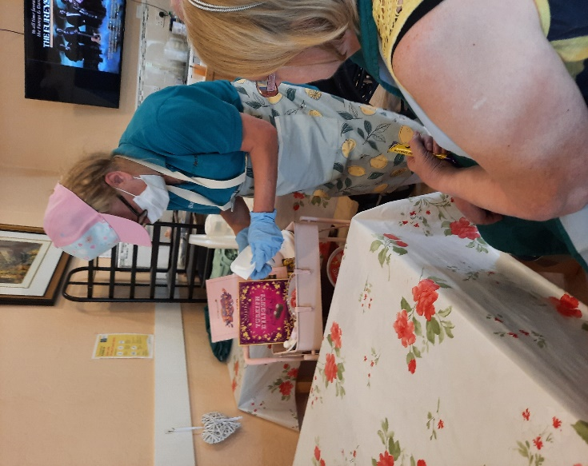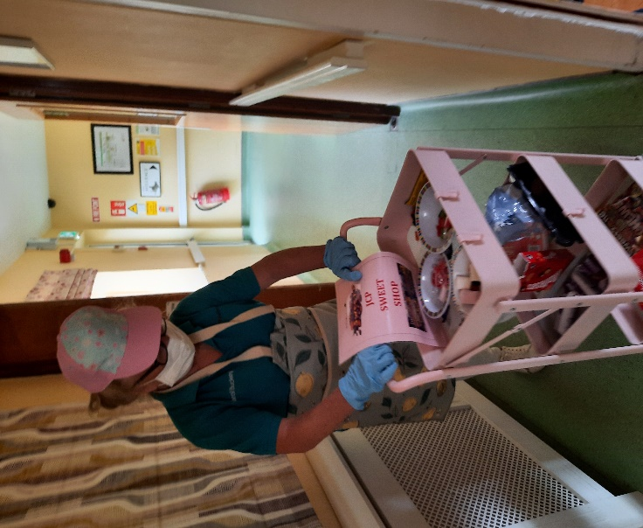

Carol loves treating the residents with her glamorous sweet trolley service

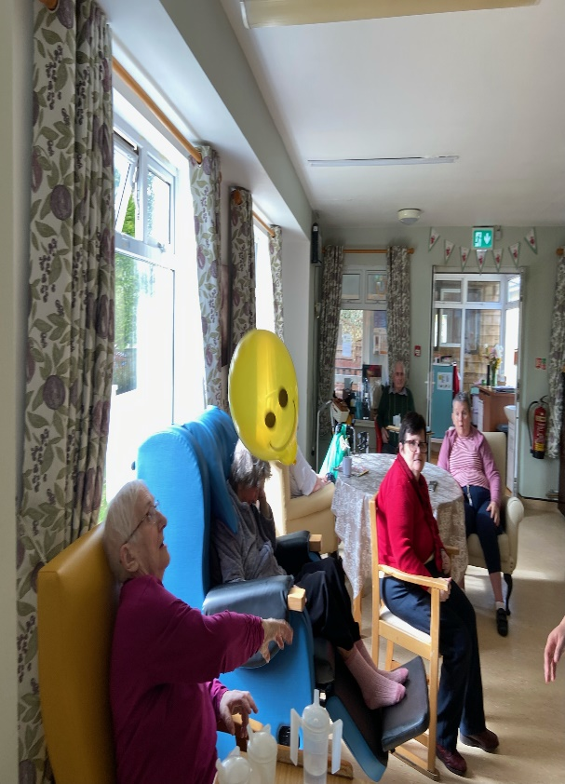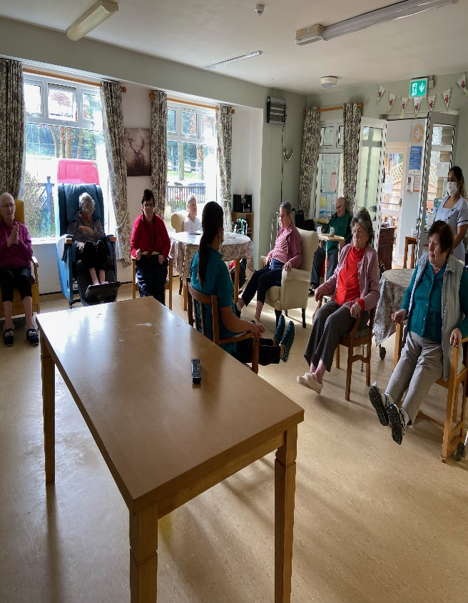

Rosemer playing balloon volleyball and seated exercise

